MALAYSIA
EVENT: THE WOLRD DAY OF REMEMBERANCE FOR ROAD TRAFFIC VICTIMS 2015
DATE: 15 NOVEMBER 2015 (SUNDAY)
TIME: 9.30 A.M. – 5.00 P.M.
VENUE: INSTITUT MEMANDU KUALA LUMPUR (IMKL), NO.3, JALAN SG. MULIA, KAMPUNG SUNGAI MULIA, 53000, GOMBAK, KUALA LUMPUR.

LIST OF GUESTS OF HONOUR:
- Puan Nora Bt Ahmad
Chief Executive Officer

- Tuan Hj. Samsudin Che Mamat
Director of Operation

- Tuan ASP Mohd Azhari Bin Hj. Chik
Senior Traffic Officer
Traffic Police Branch, Kuala Lumpur

- Tuan Che Ku Mohd Azlizam Bin Che Ku Daud
Station Chief
Fire and Rescue Station,Gombak, Kuala Lumpur

EXHIBITION/ ROAD SAFETY TALK/ OTHERS:

- Speech by CEO of IMKL
- Speech by Director of JKJR WPKL

- Exhibition by:
- Department of Road Safety
Wilayah Persekutuan Kuala Lumpur

EVENT PROGRAMME:

TIME | EVENT
9.15 A.M. | Arrival of guests and guests of honour
9.30 A.M. | The ceremony begins :-  - Singing of National Anthem “ Negaraku “  - Doa Recital  - Speech by CEO of IMKL  - Speech by Director of JKJR WPKL  - Pronouncement of Road Safety Vow (all guest)
Programme Launching Gimmick :-
- Director of JKJR WPKL & CEO of IMKL signed on the wall of pledge with message of road safety
- Presentation of token of appreciation to CEO of IMKL
 | Press Conference
 | Guests and students of IMKL signed on the wall of pledge
 | Lunch
 | Distribution of goody bags to guests
 | Exhibition and Quiz
5.00 P.M. | End of Ceremony

PROGRAMME ACTIVITIES :-

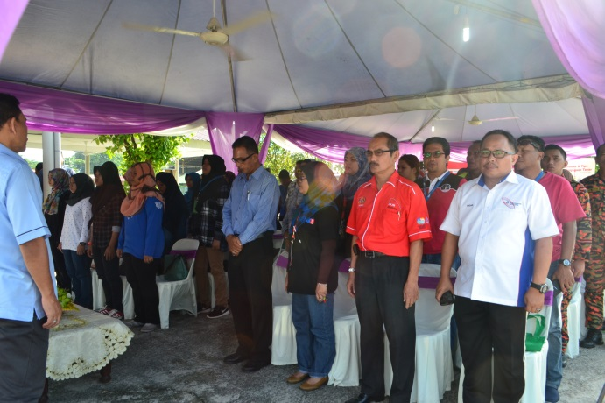
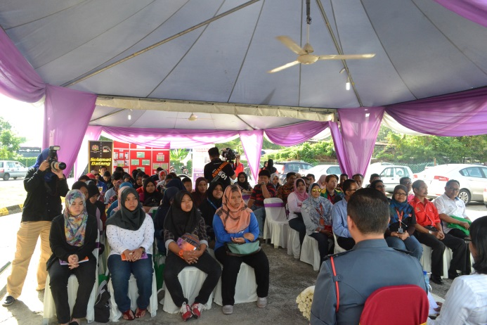

Guests and students of IMKL Singing of National Anthem ‘Negaraku’

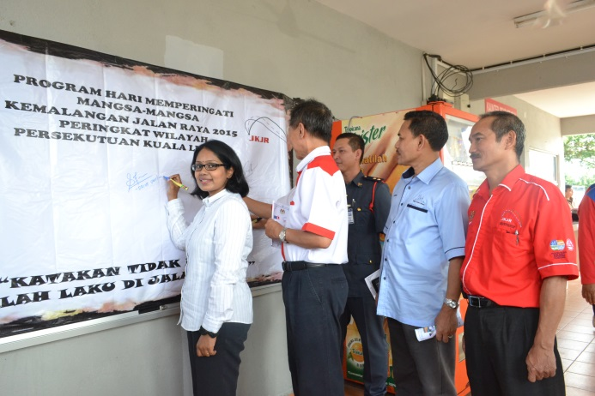
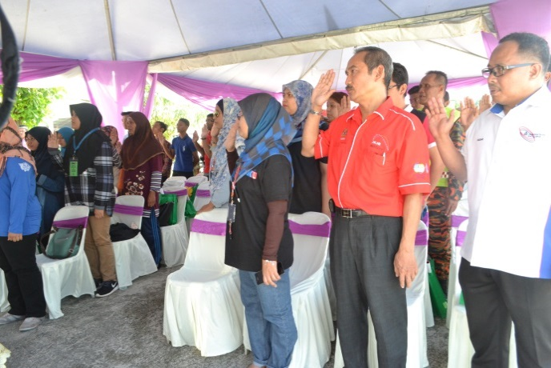

Pronouncement of Road Safety Vow Signing the Wall of Pledge
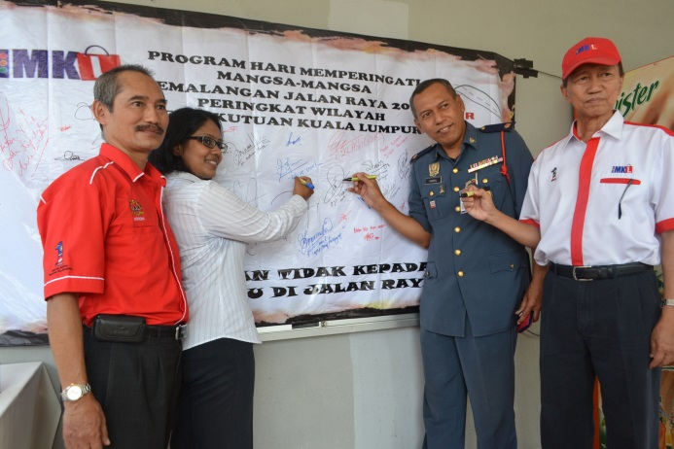

Signing the Wall of Pledge
Press Conference of The World Day Of Remembrance For Road Traffic Victims

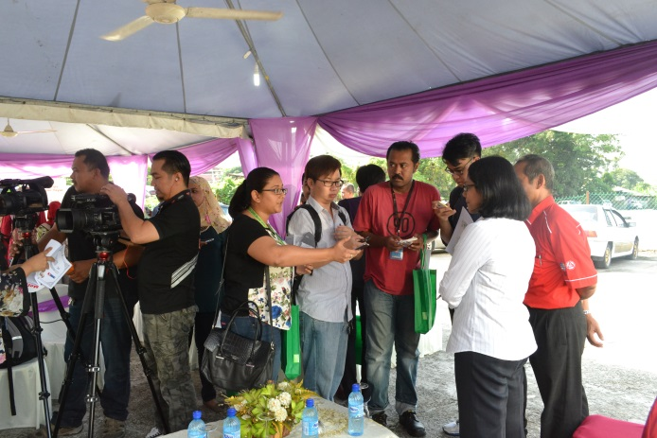

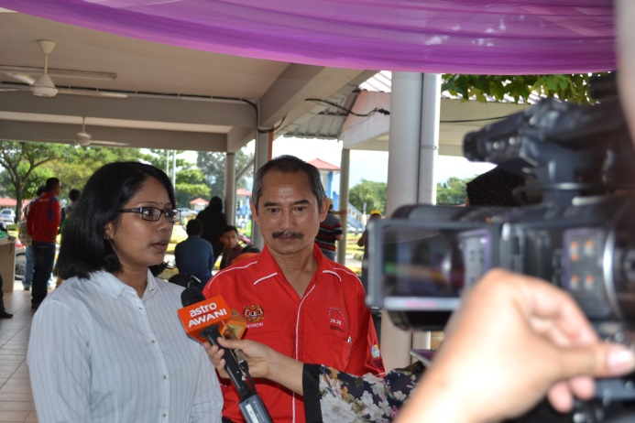

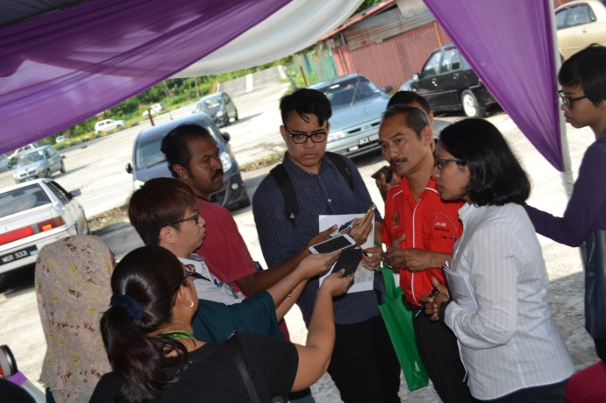

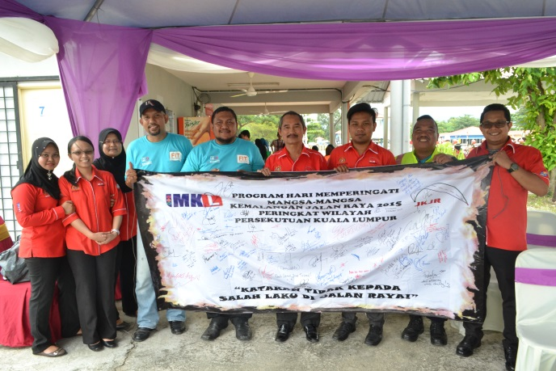
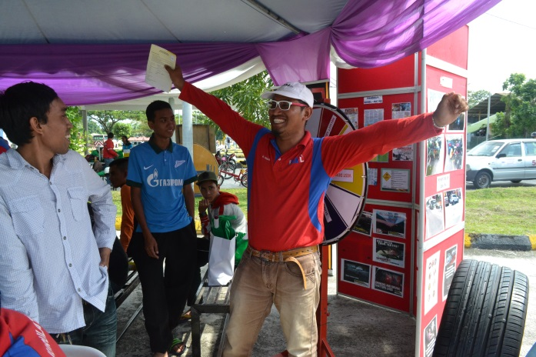
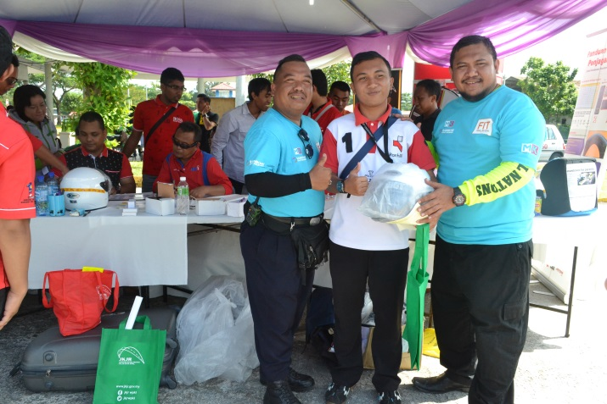
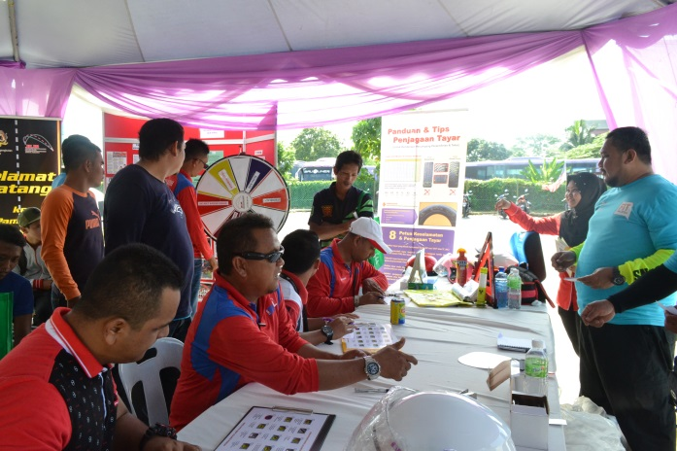
Exhibition by Kuala Lumpur Road Safety Department

