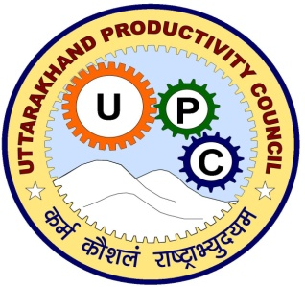 Uttarakhand Productivity Council, Dehradun

&
Arrive Safe, Chandigarh

Cordially invite you at seminar on
“ India’s biggest concern: To reduce the road casualties”
At
ROORKEE
On
12th November,2014
To commemorate the
“ UN World Day of Remembrance for Road Traffic Victims ”
Inauguration
Dr. S. Farooq, M.Sc, Ph.D, PGDBM, D.Sc, FRSH( London),
Director, Himalaya Drugs Limited

Chief Guest
Mr.R.K.Singh, Dy. Director of Factories, Uttarakhand
Key note address
Mr.Nitin Tilak, Tata Motors Limited, Pant Nagar

Program
* Inauguration - 2:00pm
* Lightening the lamp - 2:05pm
* Welcome by Secretary UPC - 2:10pm
* Inaugural address by Dr. S.Farooq - 2:25 pm
* Address by President, Arrive Safe - 2:40pm
* Key note address, Mr. Nitin Tilak - 2:55 pm
* Technical Session - 3:15 pm
* Valediction , Mr.R.K.Singh, DDF - 4.45pm
* Conclusion &Vote of Thanks - 5:00pm
* Tea - 5:.10pm
Venue- K.L.Polytechnic, Ram Nagar Chowk, Dehradun Road, Roorkee

S.P.Singh Prof. Dr. D.B. Goel Harman Sidhu
Secretary President President
Uttarakhand Productivity Council. Arrive Safe
www.upcdehradun.org www.arrivesafe.org
Phone- +91 8901285960 , 9627360558,

Co organizer- K.L.Polytechnic, Roorkee

